Кузьмина Наталья Владимировна, учитель английского языка, МБОУ «Боголюбовская СОШ имени чемпионки мира по шахматам Е.И. Быковой» Суздальского района

Методическая разработка по английскому языку для учащихся 6-7 классов общеобразовательных школ «Где отдохнуть во Владимире»
Краткая аннотация
Предлагаемый материал рассчитан на учащихся 6-7 классов общеобразовательных школ и может быть использован в рамках краеведческих тем различных УМК как на аудиторных занятиях, так и в качестве домашнего задания для самостоятельного изучения. Здесь содержатся мини-тексты о некоторых местах города Владимира, которые являются популярными у горожан и туристов. Данный материал дает ученикам наглядный пример того, каким образом они могут разнообразить свой досуг, и способствует расширению краеведческих знаний о современном Владимире. Комплекс упражнений стимулирует познавательную активность учеников, мотивирует их к иноязычному общению в рамках диалога культур.
Предтекстовый этап готовит учеников к чтению через снятие языковых трудностей и ознакомление с культурными реалиями и понятиями, которые в дальнейшем упоминаются в текстах. Задания этого этапа способствуют также развитию языковой догадки.
Задания текстового этапа направлены на проверку основного содержания текстов и восстановление пропущенной информации.
Послетекстовые задания используют лексико-грамматическое и смысловое поле текстов в качестве содержательной опоры для развития навыков письменной речи.

Recreation places in Vladimir
 | Vladimir is really an old city so history-lovers can visit a lot of interesting places here: historical monuments, museums, ancient cathedrals, etc.
But Vladimir is a modern town as well. Both adults and teenagers can find something for their recreation. Would you like to learn more about the town facilities for tourism and recreation?
Glossary:
- recreation = something that you do as a hobby or to have a good time | - facilities = объекты

STEP 1. PREREADING TASKS
Task 1. You are going to learn some facts about several places in Vladimir. Match the Russian names and their English equivalents. There is one extra English name. Can you translate it into Russian?
- Исторический музей  - Ледовый дворец Полярис  - Музей природы  - Мастерская шоколада  - Музей иллюзий и наук Да Винчи | - Natural History Museum  - The Big Wheel Sky 33  - Museum of Illusions and Sciences Da Vinci  - History Museum  - Polyaris Ice Dome  - Chocolate Workshop

Task 2. Enrich your vocabulary.
А. In the texts you will find several new words. Try to understand their meaning with the help of definitions in the table.
words | definitions | your translation
display (n) | a number of things for people to look at or to buy
be situated | be in a certain place or position
local (adj) | characteristic of the place where you live in, or the area you are talking about
amazing (adj) | very good and surprising
surroundings (n) | all the objects, buildings, natural things etc that are around the area you live in
informative (adj) | giving a lot of useful facts or ideas

B. Write these words down in your vocabulary-books. Consult a dictionary if necessary. Learn the words by heart.
Task 3. Try to predict what people can do in these places.
I think,  I believe, | people | can | see…  learn some facts about…  have a look at …  have a ride…  try to…  skate  have a good time | in…  at…

STEP 2. READING TASKS
Task 4. Read the texts and check if your predictions (ideas) were right. Match the texts with the pictures.
A 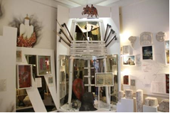 | B 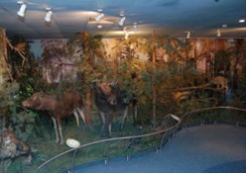
C 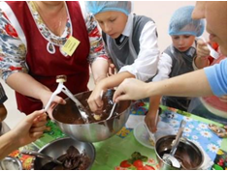 | D 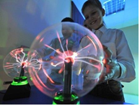
E 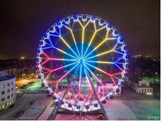 | F 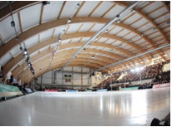
- Natural History Museum is the right place to visit for those who would like to know more about the flora and fauna of Vladimir region. Its displays show stuffed animals and birds, pictures of local natural areas on the walls. The museum is especially interesting and informative for children who will be able to listen to birds’ singing ……. . They can also measure their own weight in a number of animals with the help of a special device.
- Sky 33 is one of the ten largest big wheels in Russia. …..… so it is easy get there by bus. It is 50 metres high and has 32 capsules for 6 people each. Take a 15-minute ride and you will see a wonderful panorama on the historical and industrial parts of Vladimir (70% of the city territory can be seen from the top of the wheel), at the beautiful surroundings and the River Klyazma.
- Are you fond of sports? Enjoy skating in Polyaris Ice Dome …….. . Come and watch different sports competitions, hockey matches and ice shows. A fitness club and a café are situated here too.
- Science can be a real fun. Do you agree with that? In Museum of Illusions and Sciences Da Vinci you will have a good time doing physical and chemical experiments, …….. . Amazing master-classes and exciting quests are waiting for you as well.
- History Museum is situated in the centre of the city …….. . It is easy to get there by bus or by taxi. The museum has a very interesting display telling the history of Vladimir from the ancient times till the 1917 Revolution. Here you will see a lot of artifacts, such as a mammoth tusk, ancient weapons, clothes, etc.
- Have you got a sweet tooth? Would you like to learn the history of chocolate? Would you like to …….. and make a chocolate bar with your own hands? Visit our Chocolate Workshop! Come with your parents or friends. Groups of 20 are also welcome. Every guest gets a sweet souvenir.

Task 5. These phrases were missing from the texts. Match the phrases a-g with the texts 1-6. There is an extra phrase.
- any time of the year
- taste different kinds of chocolate
- or to watch videos about the local wildlife
- and learn a lot of interesting facts about
- and taking unusual photos of yourself
- in a nice old building
- it is situated in the Central park

STEP 3. AFTRE-READING TASKS
Task 6. Imagine that a group of teenagers from an English partner-school came to Vladimir. They all have different interests. Help them choose a place to their tastes to spend a Sunday afternoon. And where can you go all together?
Example: Tom could visit…. There he would see/learn about/ make/do… .
Tom: Science is amazing! Experiments are great! Not long ago I joined Robotics Club. | Steve: I am fond of sports. My favourite hockey team won the championship last year. I watch all their games.
Ben: I am interested in Biology and I have got a big collection of butterflies. | Millie: I am fond of cooking. I like making desserts most of all.
Sally: I am interested in history. I am especially fond of ancient times and I would like to learn how people lived in that period. By the way, did mammoths live in your area in prehistoric times?

Task 7. Write about any other place in Vladimir (or in your native town) and invite the English teenagers to visit it. Use the new words and the phrases from the texts. Mention the following:
- where this place is situated
- how they can get there
- what they can see and do there
- if it will be interesting for everyone
THE KEYS
Task 1. 1d 2e 3a 4f 5c b-extra (Колесо обозрения Небо33)
Task 2. display – выставка; be situated – быть расположенным; local – местный; amazing – удивительный, изумительный; surroundings – окрестности; informative – информативный, содержательный, полезный
Task 4. 1b 2e 3f 4d 5a 6c
Task 5. 1c 2g 3a 4e 5f 6b d-extra

